Leader Overview
Today, we are learning that God loves everyone, even people who we might not necessarily like. God sent Jonah to the Assyrian capital city of Nineveh to warn them they needed to change their ways or be destroyed. Jonah didn’t want to go because he didn’t like the people of Nineveh. They were a very powerful and scary nation. God wants us to share His love with everyone, even people we don’t like. We do this because God wants us to love everyone just like He does.

Bible Lesson
Jonah Is Called to Nineveh
Jonah 1:1–2; 3:1 to 4:2
Faith Fact
God loves everyone.
Faith Verse
2 Corinthians 5:7 (NLT)
For we live by believing and not by seeing.

Preparing for the Session
Leader Preparation Time: 20–25 Minutes
You Will Need
Large Group
- Bible
- Worship songs (Song suggestions: “All of Me” by Gateway Kids Worship; “This Is Amazing Grace” by Bethel Music Kids; “It’s Your Love” by Gateway Kids Worship)
- For groups not using a phone or tablet only, add:
• Projector or TV
• Laptop
• Rules Video or Slide
• Faith Fact Slide
• Faith Verse Video or Slide
• Bible Lesson Slides 1–11
• Bible Lesson Video A
• Bible Lesson Video B
• Paper, one per kid
• Pencils or pens
Small Group
- Small Group Group Connection
- Small Group Faith Verse Review
- Poster board
- Tape, glue, or sticky dots
- Scissors
- Small Group Activity Page, one per kid
- Crayons, colored pencils, or markers

To download session videos, slides, and printables, visit: BibleEngagementProject.com/downloads

Getting Ready
Large Group
- Download videos and slides if needed.
- Select worship song(s) and have them ready to play.
Small Group
- Print the Small Group Group Connection.
- Print the Small Group Faith Verse Review.
- Cut out the word groups so the entire verse can be attached to the front of the poster board.
- Attach the words to the poster board with glue, tape, or sticky dots.
- Cut out the hearts from the Small Group Faith Verse Review.
- Print copies of the Small Group Activity Page, one per kid

First time leading Listen for Kids? Check out the Facilitator Guide.
Large Group
30 Minutes
See what’s needed at the beginning of the session.

Introduction
Welcome! Are you glad you came today? I know I am glad you are here. I have a question for you. Have you ever had to spend time with someone who had been mean to you or bullied you? (Group response)
I know all of us have had people in our lives who haven’t treated us well at one time, and sometimes that can make us feel like we never want to spend time with them again. Maybe that is a person at school, a relative, or someone who lives in your neighborhood. What if you were told you had to spend a whole day with that person so he or she didn’t get in trouble? How would that make you feel? (Allow response)
Today, we are going to hear about a guy who didn’t like the people who lived in a particular city because of the way they treated God’s people. God wanted the guy to go tell them the truth about Him anyway. You see God loves everyone, no matter how badly they might behave.
That is our Faith Fact for today! Let’s say it all together. God loves everyone.
• Show the Faith Fact Slide.
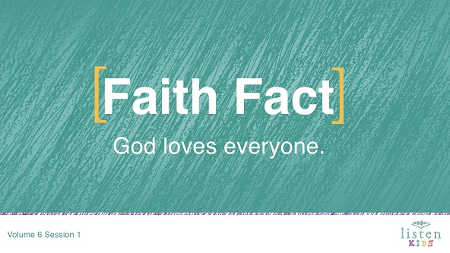
Let’s say it one more time, but this time let’s see if we can do it an accent as if we were from a different part of the country, such as Texas or Chicago. Here we go. God loves everyone. Great job!
Rules Review (Optional)
Before we dive into the rest of the session, let’s look at the rules we follow as a way to show love to one another. Let’s watch the video now.
• Play Rules Video.

Game
Go to Nineveh
The man in today’s story was named Jonah. He was given clear directions from God to do something, but Jonah chose to do something very different instead. He thought he could run from what God was telling him to do, but it’s not easy to escape God’s plan.
Today, we are going to play Go to Nineveh, which is similar to the game Sharks and Minnows. In this game, one person is going to stand in the middle of the room and everyone else will line up across one of the walls. When the person in the middle shouts, “Go to Nineveh,” all the other kids have to journey across to the other side of the room without being tagged by the person in the middle.
If you get tagged, it’s important that you join the team in the middle and help tag others in the next round. Every time the team in the middle wants the other players to start crossing the room, they have to shout, “Go to Nineveh.”
• Depending on time and number of kids, play this game a few times.
That was so much fun! Head back to your seats. Today, we are hearing about someone who was sent to warn the people of Nineveh that God would destroy them if they did not change the way they were living their lives. Jonah tried to escape God’s plans for him. Do you think he succeeded? (Group response) Before we learn more, get on your feet for worship. Here we go!

Worship
God loves it when we worship. One of the ways to worship God is by singing. Let’s worship Him together as we sing.
• Lead the kids in singing one or two praise songs. See suggestions at the beginning of the session.

Bible Lesson
You did such a great job worshipping God! I love singing my worship to God, and I know He loves to hear our voices. We are going to be learning more about His love for us today from the Bible. Before we dive into our Bible story, let’s bow our heads and pray together.
Prayer
Dear God, thank You for loving me. Thank You for loving not only the other kids in this room but loving everyone in the world! Help us learn from Your Word today. Amen.
Video Intro
Before we get started with the Bible story, let’s check in with the Challenge Accepted team and see what they’re up to!
• Play Bible Lesson Video A.
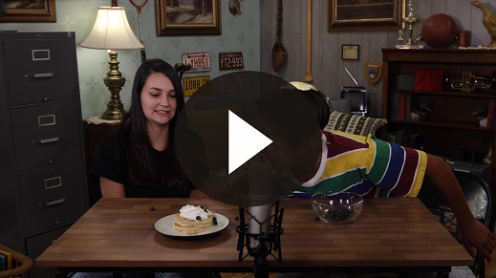
Wow! Would you like to try that challenge? (Group response) Moving blueberries with a straw is hard enough, but I don’t know about balancing an omelet on my head at the same time! That’s crazy! Let’s look at our Bible story for today.
Bible Story
Now, it is time to challenge our faith and look at a real experience that occurred in the Bible. You might need help finding this book, but we are going to Jonah 1:1–2.
We have been hearing about how Israel demanded a king. God warned the people that if they wanted to be like other nations, they would face the bad consequences that come from having a human king. Israel was divided after Solomon’s son became king.
Some of the kings of Israel worshipped false gods, and they picked fights with other nations. One of the enemies of Israel during this time was the Assyrians. The Assyrians were known to treat nations with cruelty.
The capital city of Assyria was Nineveh. God didn’t hold back what He thought about Nineveh when he spoke through the prophet Nahum. God said, “What sorrow awaits Nineveh, the city of murder and lies! She is crammed with wealth and is never without victims.” (Nahum 3:1). Wow! Doesn’t sound like a place I would want to go either!
Nineveh was a city of violence, known for its brutal treatment of people. God was unhappy with them and He planned to destroy the city. This is where the prophet Jonah’s story starts in Jonah 1:1–2. Let’s read it.
• Read or have a kid read Jonah 1:1–2.
• Show the Bible Lesson Slide 1.
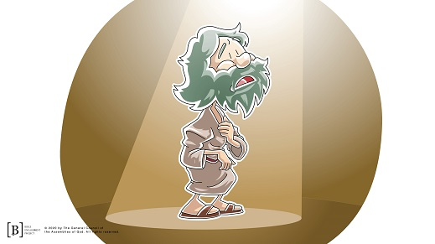
Can you imagine if you were praying or maybe worshipping God, and suddenly God talked to you? How awesome would that be? Then, imagine if God told you that He was going to make that kid at school who had been bullying you pay. You might say, “Get him God!” Best day ever!
Instead, God says that He actually loves the bully at your school and wants you to warn him to change the way he is acting before God wipes him out. Ugh! You might say, “God, I want You to wipe him out because he is so mean to me.”
That is exactly what Jonah was feeling. The Assyrians were an incredibly mean nation. They didn’t obey God in any part of their lives. Jonah wanted to see God destroy the people of Nineveh, but God had another plan because God loves everyone.
Instead of going to Nineveh, Jonah went the opposite direction toward a place called Tarshish. He bought a ticket to travel on a ship, and they set sail. Jonah thought he had escaped God’s plan. Do you think God was finished with Jonah? (Group response)
• Show the Bible Lesson Slide 2.
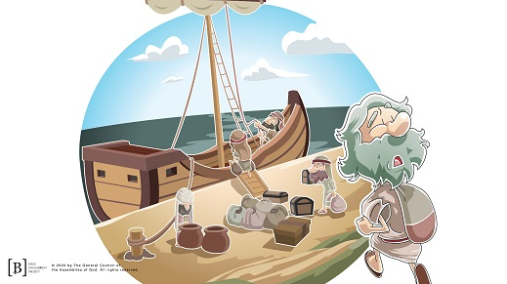
God had other plans. He sent a powerful wind over the sea that caused a violent storm. There was a chance that the storm could have broken the ship into pieces. Everyone on board was afraid for their lives and did everything they could to save the ship, including praying to their gods and throwing their stuff overboard.
• Show the Bible Lesson Slides 3 and 4.

Everyone was scared except Jonah, who was asleep in the lower deck of the ship. The captain woke Jonah and asked him to pray to his God for help. Jonah told everyone on board that it was his fault because he was running away from God.
• Show the Bible Lesson Slide 5.
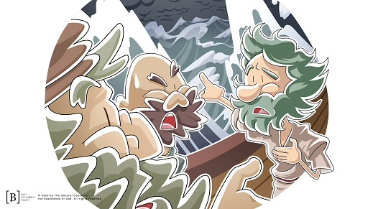

He told them that if they would throw him into the sea, the sea would be calm again. The sailors decided to try harder to get to land, but eventually, they realized the only way to survive was to throw Jonah into the sea.
• Show the Bible Lesson Slide 6.

Do you think God was finished with Jonah now? (Group response) Nope, the Bible tells us that God had arranged different transportation for Jonah.
• Read or have a kid read Jonah 1:17.
• Show the Bible Lesson Slide 7.
Jonah ended up being swallowed by a giant fish, and he was inside the fish’s belly for three days and three nights. Do you think God managed to get Jonah’s attention? (Group response) Jonah recognized what he did wrong, and he agreed to go to Nineveh. God has a way of getting our attention and getting us back to where we need to go.
• Show the Bible Lesson Slide 8.
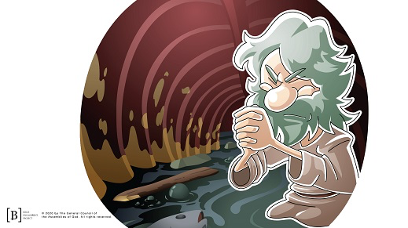
God ordered the giant fish to spit Jonah onto the beach, and again He told Jonah to go to Nineveh.
• Show the Bible Lesson Slide 9.
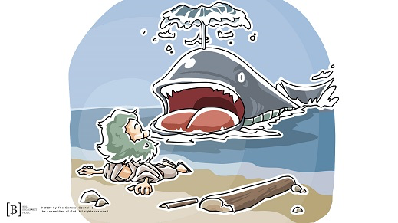
Jonah was not happy about it, but he headed for Nineveh after God told him a second time to go. Let’s see what the Bible says happened in Jonah 3:4–5.
• Read or have a kid read Jonah 3:4–5.
Jonah told the people of Nineveh that God was going to judge and destroy the city if they didn’t change their lives, and they listened. They stopped doing the sinful things they were doing. They repented and asked for God’s forgiveness as they stopped doing things that displeased God. Even the king declared that everyone needed to stop what they were doing and pray to God. They hoped that if they changed the way they were living that God would not destroy them.
• Show the Bible Lesson Slide 10.
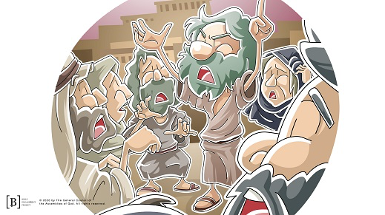
What do you think God did? (Group response) I mean they were bad people. What is our Faith Fact for today? God loves everyone. He even loves those people we think might not deserve His love. Let’s read how God responded in Jonah 3:10.
• Read or have a kid read Jonah 3:10.
How exciting is that if you lived in Nineveh? Even though they deserved to be destroyed, God chose to save them because God loves everyone.
But there was one person who wasn’t very happy. Can you think who that may have been? Let’s read about it.
• Read or have a kid read Jonah 4:1.
• Show the Bible Lesson Slide 11.
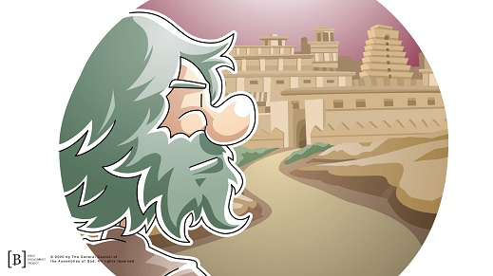
You see Jonah actually wanted God to destroy the people of Nineveh because they were mean people. But God loves everyone and doesn’t want to see anyone destroyed. Jonah actually threw a big fit because he was so upset. Jonah didn’t understand that God wanted the people of Nineveh to love Him more than He wanted to destroy them.
Teaching Time
Sometimes we can be like Jonah and want bad things to happen to people, especially people who act, think, or look different than we do. But is that what God wants? God wants everyone to have a relationship with Him. Let’s look at this verse from the New Testament.
• Read or have a kid read 2 Peter 3:9.
Remember today’s Faith Fact. God loves everyone. I’m glad God doesn’t wipe me out every time I make a mistake. I need to change the way I think so that I love people the way He does. When I show them God’s love, it gives them the opportunity to see God in me.
Faith Verse
We live in a world where some people don’t like people who look or act different from them. We know that God loves everyone because the Bible shows us this. It takes faith to know that God not only loves me but also loves others as well. Let’s take a minute and learn our new Faith Verse from God’s Word that talks about believing. Let’s learn the actions together.
• Play Faith Verse Video.
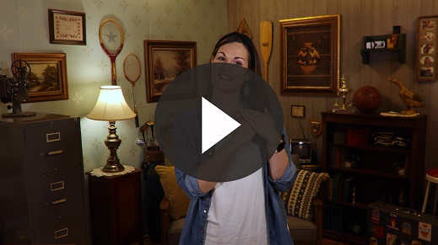
2 Corinthians 5:7 (NLT)
For we live by believing and not by seeing.
That was an easier one, wasn’t it? Although we may only see the bad parts of people, God sees the way they can be changed with His love. It takes faith to see what God sees in someone we don’t like very much.

Prayer and Response
Consider playing a worship song softly in the background while kids pray.
You Will Need
- Paper, one sheet per kid
- Pencils or pens

No prep needed for this activity.

Let’s pray that God will help us see the way He sees. We know that God loves everyone, but sometimes it is hard for us to love certain people. I want you to pause for a minute and think of someone in your life right now that you don’t like very much. This is could be someone who hasn’t treated you or your friends kindly. Write their name or draw a picture of them on that piece of paper.
Now take that piece of paper and wrinkle it into a ball. It might feel good right now to throw that piece of paper away because we really don’t like that person. But instead of throwing the paper ball across the room or in the garbage, we are going to pray that God will help us love them the way He loves them because God loves everyone.
Let’s pray quietly for God to show us the love that He has for that person written on our paper. Ask God what you can do to show him or her God’s love. Then, unwrinkle the piece of paper and pray for that person by name. Ask God to help that person discover God’s love and ask how you can show him or her His love.
• Give kids time to pray. Then introduce the worship song. This could play in the background while kids pray or could be a worship song to sing together.
Worship Song
Play a worship song.
Video Wrap-Up
Before we go to our small group activities, let’s see how the Challenge Accepted team is doing.
• Play Bible Lesson Video B.
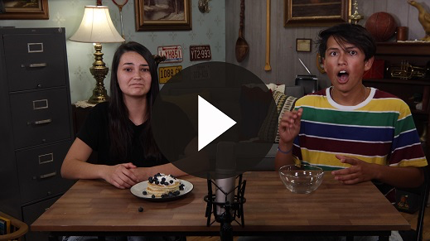
Let’s all accept their challenge that they gave us! Be sure to pray for that person who has been mean to you. Let’s choose to show love and kindness to others, even those that we don’t like very much. When you want to be upset at them or wish harm would come to them, let’s remember our Faith Fact.
• Show the Faith Fact Slide.

Say it with me. God loves everyone. Even people who don’t like me or I don’t like very much? Everyone! Let’s say it one more time together. Thanks for a great time learning about God together.
• Dismiss kids to Small Group time or to go home if your group time ends here.

Small Group
30 Minutes
This section can be done in conjunction with the large group, or on its own if you do small groups with your kids. During Small Group time, the goal is to connect the kids with the Word of God and to each other. All activities are led by the small group leader.

Group Connection
Loving All People
You Will Need
- Small Group Group Connection
Getting Ready
- Print the Small Group Group Connection.

Today, we’ve heard how God loves everyone! We’ve also learned that He wants us to love everyone like He loves them. Let’s take some time as a group to consider different kinds of people we might meet in the world.
Let’s consider all of the different ways we could show God’s love to the different people we might meet. I’ll show a picture of someone, and we can go around the group and share ideas to show love to that person.
• Show the pictures of different people. For each photo, ask the kids how they might show love to those in the photo.
We are all so different! Even each one of us in this group like different things, we look different, and we act differently, but God loves each one of us. He wants us to love everyone, too, no matter how different they might be.

Bible Lesson Recap
You Will Need
- Bible, one per kid

No prep needed for this activity.

Bible Story Review: Jonah 1:1–2; 3:1 to 4:2
Today’s Bible story teaches us that God loves everyone. Turn to the Book of Jonah, and let’s split this reading up into sections.
• Divide the Bible reading into smaller chunks for kids to read aloud.
Some people think that God is just waiting for us to mess up so He can destroy us or punish us. Some people actually hope God will punish other people because they don’t like them. Yes, there are times in the Bible when God punished people for their sins, but we can see that isn’t what God wants to do. God wants people to change their bad choices and follow Him because God loves everyone.
Faith Fact
The Book of Jonah reminds us over and over again that God is not a mean God but a loving God. That is what our Faith Fact says.
• Show the Faith Fact Slide.
Say it with me: God loves everyone. That was great!

Group Discussion
Feel free to use all or just a few questions as a jumping-off place for good discussion. Questions marked with * are designed for more conversation. Adjust the questions based on the age or maturity of your group. Typically, older kids will be able to dive a little deeper than younger ones.
Questions
Today, we learned that God loves everyone. What does that mean?
Why do you think Jonah didn’t want to warn the people of Nineveh?
What was the name of the city that Jonah tried to travel to instead of going to Nineveh?
* Give an example of a time you felt like Jonah did in our story today.
How would you respond if someone told you your entire city was going to be destroyed? What are some of the things that the people of Nineveh did to show they had repented?
What happened after Jonah warned the people of Nineveh? Do you think that God was pleased with what the people did? Why do you think that?
How did God show His love to Jonah in the Bible story?
Let’s read 2 Peter 3:9 again. What does this verse tell us about God’s desire for people?
* If you had to write a book report on Jonah, what are some things that you would say about Jonah? Can you say any of those same things about yourself?
Earlier you prayed for someone that you may have had a problem with in the past. How can you show that person that God loves everyone, including him or her?

Application and Response
God wants us to love everyone the way that He does. God desires for all people to obey and follow Him, and He tells us to share that good news with them. Sometimes we may not want to because we have our own opinions. Let’s not forget that God loves everyone and tells us to do the same.
Make It a Habit
Select a simple visual reminder of the session’s Faith Fact.
Let’s make a habit to help us remember what we heard today. Put your hand up in front of you, palm outward. Make a J with your thumb up into your pointer finger. Then pretend each of your other fingers are a letter. Whose name in our story today starts with a J and has a total of five letters? (Jonah)
When I put my palm out to push people away it reminds me of Jonah. When I remember that God loves everyone, it reminds me that I need to be like Him and give someone a high five. Instead of pushing people away, I can greet others and remember that God loves everyone.
Prayer
Let’s pray and ask God to help us.
Father God, thank You for loving me even though I sometimes make bad choices. Thank You for helping me to love others the way You do and to share the good news with them. I want to love others the way that You do. Amen.

Faith Verse Review
You Will Need
- Small Group Faith Verse Review
- Poster board
- Tape, glue, or sticky dots
- Scissors
Getting Ready
- Print the Small Group Faith Verse Review
- Cut out the word groups so the entire verse can be attached to the front of the poster board
- Attach the words to the poster board with glue, tape, or sticky dots
- Cut out the hearts from the Small Group Faith Verse Review

Our Faith Verse for today is 2 Corinthians 5:7. It talks about what faith really is—believing even though we can’t see something. Let’s say the Faith Verse and do the actions for the verse together.
• Show the Faith Verse Slide.
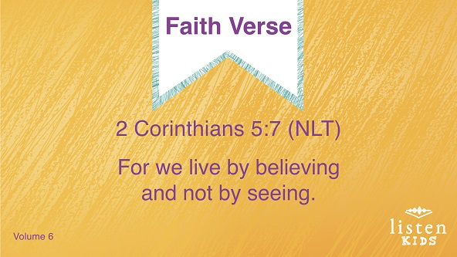
2 Corinthians 5:7 (NLT)
For we live by believing and not by seeing.
Faith Verse Fun
Love Letter
You did a great job! Let’s see if we can pass this Faith Verse challenge. On this poster board, I have our Faith Verse. We are going to say it together. Then, I will place a heart over some of the words to see if we can say it without being able to see all of it. Ready?
• Place a heart over a couple of the words with glue, tape, or sticky dots.
• Have the kids say the verse.
• Repeat hiding words and saying the verse until the entire verse is hidden.
Now that we have covered the entire verse with hearts. Do you remember what our Faith Verse is for today? Even though we can’t see God’s love, we believe that He loves each and every one of us!

Creative Activity
Jonah and the Giant Fish
You Will Need
- Small Group Activity Page, one per kid
- Crayons, colored pencils, or markers
Getting Ready
- Print copies of the Small Group Activity Page, one per kid.

Wasn’t today’s story great? Jonah had some difficult lessons to go through, but in the end he learned that God loves everyone. What are some ways we can show God’s love to others?
• Have the kids color the picture.
Let’s pray and thank God for His love.
Prayer
God, thank You for sending someone into my life to let me know that You love me and want me to live in a way that pleases You. Help me to love others the way that You love me. Amen.

Faith Fact Recap
• Display the Faith Fact Slide as parents are coming into the room.
• Maximize the time you have with your kids, so that parents see what their kids have learned. Have the kids repeat the Faith Fact, and then dismiss them to their parents.
Today as you go home, let’s remember our Faith Fact. Let’s say it together one more time.
• Show the Faith Fact Slide.
God loves everyone. That’s a really important take-away from today.

Dismissal
• Send home the Small Group Activity Page with each kid.
• Remind parents that there are Family Devotions available on the app to do with their kid.
• Tell everyone the date and time for the next session.

